**Web Scraping and Data Visualization of India's Largest Companies**

**ScreenShots**

1. **BarPlot:**

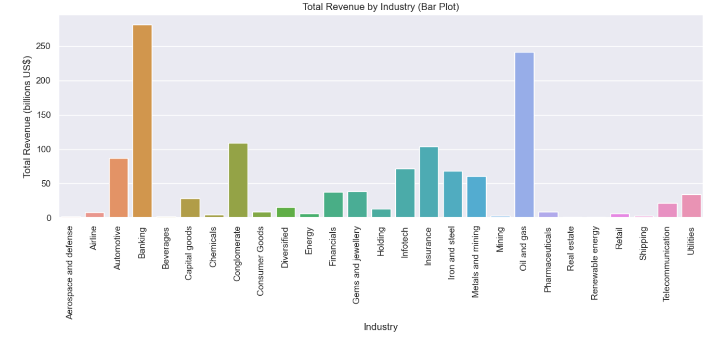

**2.Pie Chart :**

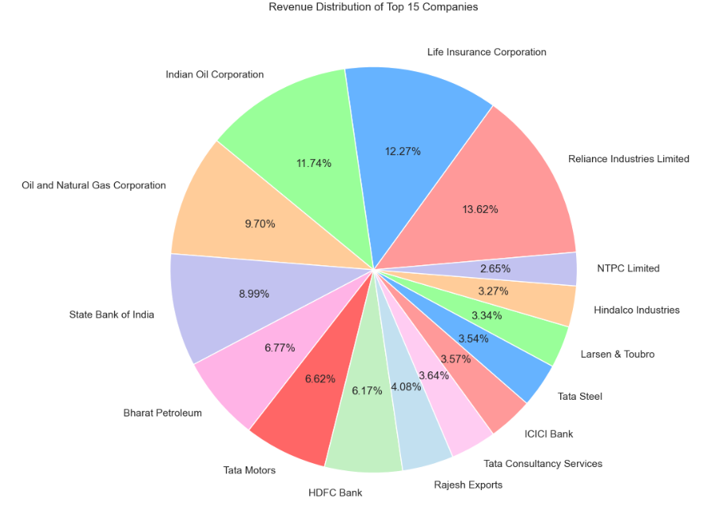

**3. Histogram Plot :**

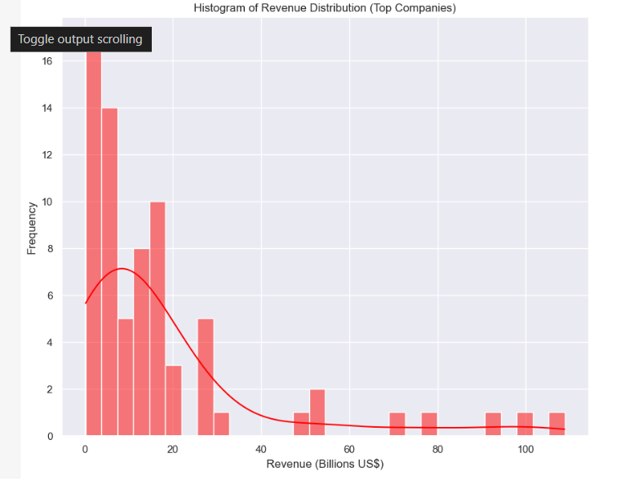

**4. Scatter Plot:**

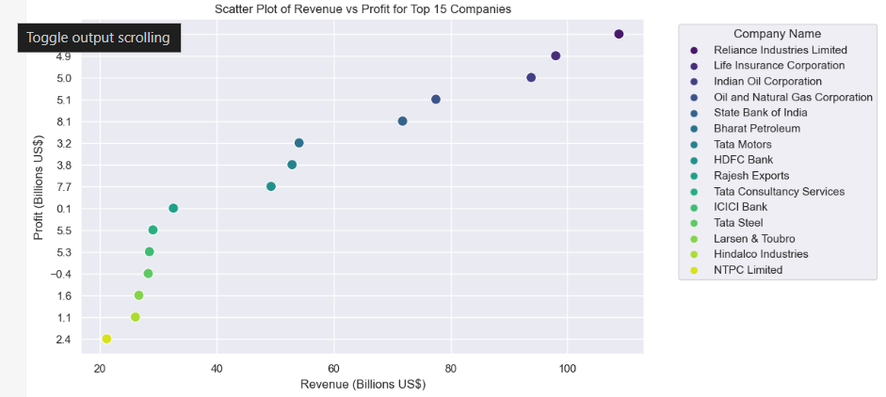

**5. Line Plot :**

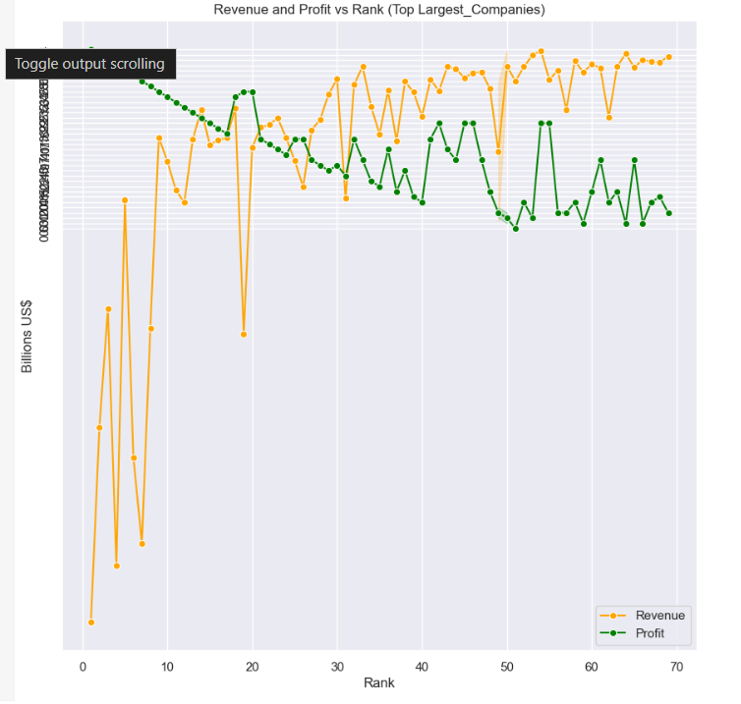

**6. Area Chart:**

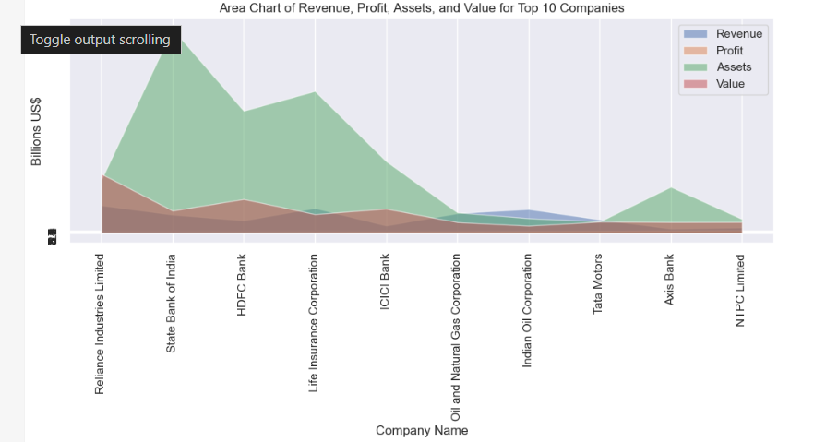

**7. Violin Plot :**

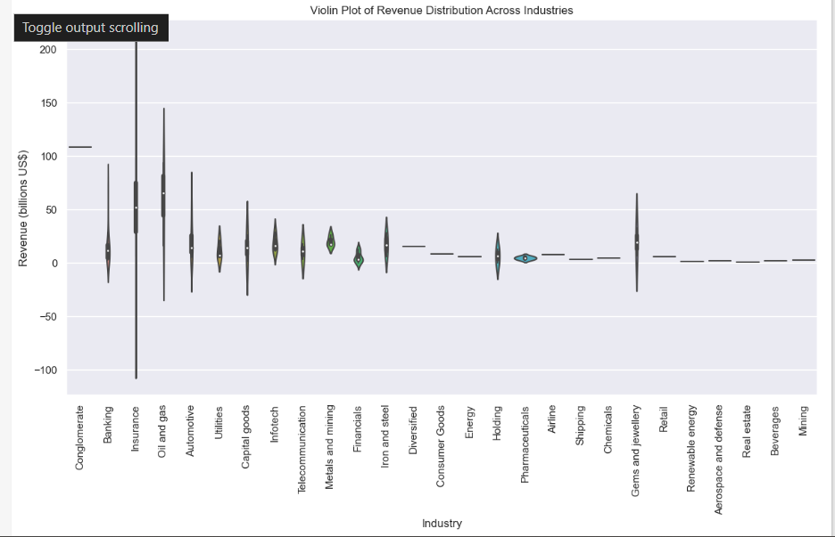

**8. Pareto Plot :**

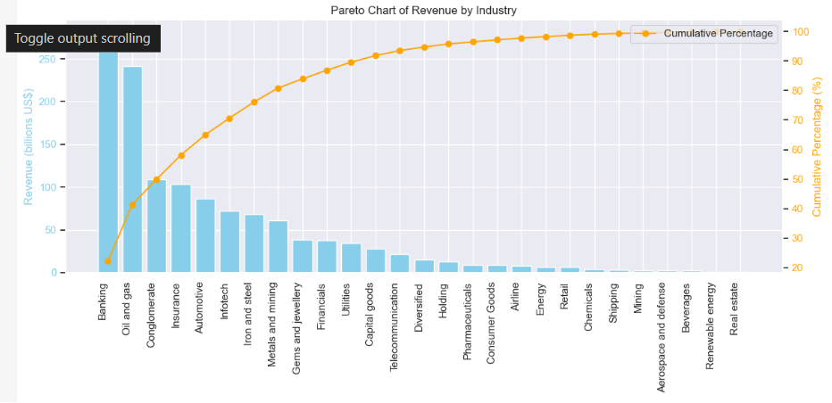

**9. Stem Plot :**

